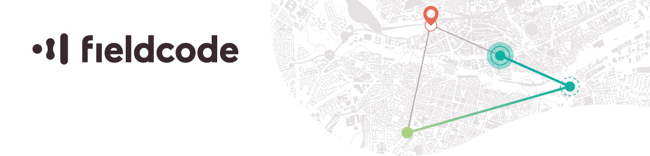

(Senior) Java Developer (m/f/x) – Athens

Fieldcode is a Field Service Management (FSM) software created from 20 years of global field service expertise with the highest customer service standards that is working towards climate positivity. Our Product & Development departments are based in Greece, Germany, Poland and Hungary and collaborate closely and effectively in creating an innovative, easily accessible and game-changing software experience. As an experienced Software Developer, you will join our software engineering teams and take part in making our product better day by day.

* As a Software Developer you will join a team coding in Java 11+, Scala, Kotlin and Swift and work with technologies like Camel, Kafka, ElasticSearch, MongoDB, Hazelcast, Keycloak and many other technologies that are already being tested and integrated in our test, integration and production environments running on AWS Kubernetes clusters. Quality and deployment automation relies on Azure in combination with SonarQube and Nexus. For monitoring and debugging purposes you will use tools like Kibana, Grafana, Prometheus, Jaeger and PRTG
* You work "agile" - which does not mean that you and your colleagues obsessively stick to Scrum, but rather that you implement our feature- and innovation-driven development process in a way that makes the most of the prevailing approaches

**Our requirements**

* You are passionate about software development with focus on Java 11+ features, Microservice Architecture Patterns, Design Patterns, Spring Boot 2.x essentials, REST, Camel, Kafka, MongoDB, Hazelcast, git, Maven, unit testing
* At best you additionally gained some experience with Drools, Optaplanner, RxJava - this is not mandatory but would be a plus
* You have a very pronounced team spirit and enjoy working with likeminded English-speaking professionals
* You are familiar with agile software development
* You are willing to grow and craft in an environment similar to a start-up and to work with state-of-the-art technologies
* Your English skills are excellent

**We offer you**

* A secure job in an innovative, international software company with IoT
* Great team spirit and a great working atmosphere
* Direct and open communication
* Mentoring program to facilitate the onboarding process
* Room for own ideas and suggestions for improvement as well as their quick implementation due to our very short decision-making processes
* A company that not only achieves economic success, but also works hard to make the world a better place:
* We invest heavily in research into high-quality technologies with a drastic impact on CO2 reduction. Although there are few researched and valid methods to influence CO2 negativity, we want to be at the forefront and support leading scientists and projects
* Our office is located close to the city center and you have the flexibility to work from home in alignment with your supervisor

**Who we are**

We develop Field Service Management software to achieve CO2 negativity and offer cost-effective and environmentally friendly solutions. We are working hard to provide cutting edge technologies, innovative sustainability measures and exceptional service.

Let’s make the world a better place – together! Send us your application by email to [jobs.8415@fieldcode.com](mailto:jobs.8415@fieldcode.com). We look forward to hearing from you.

Please visit us on our [website](https://fieldcode.com/)!